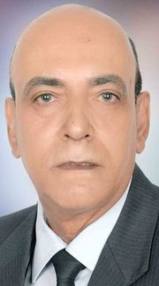

Curricum vitae

Name: First: Dr. Gamal
Middle: Mohamed Abdallah - Surname: El-Sayed - Position: Lecturer
Date & Place of birth: 20/9/1953 Tahta-Souhag
Gender: √ - Male - Female
Phone: 088 - 2343031 - 01228529977
Fax:-
E mail: gmohamed1953@Yahoo.Com.

Academic Qualifications

Degree | Date | University  (name & Location) | Specialization
Ph.D. | 1989 | V.S.B - CZECHOSLOVAKIA | Geochemistry and Petrology
M.Sc. | 1985 | Assiut University - Assiut | Stratigraphy and Sedimentology
B.Sc. | 1976 | Assiut University - Assiut | Geology

